

GA NORTH MUNICIPAL ASSEMBLY
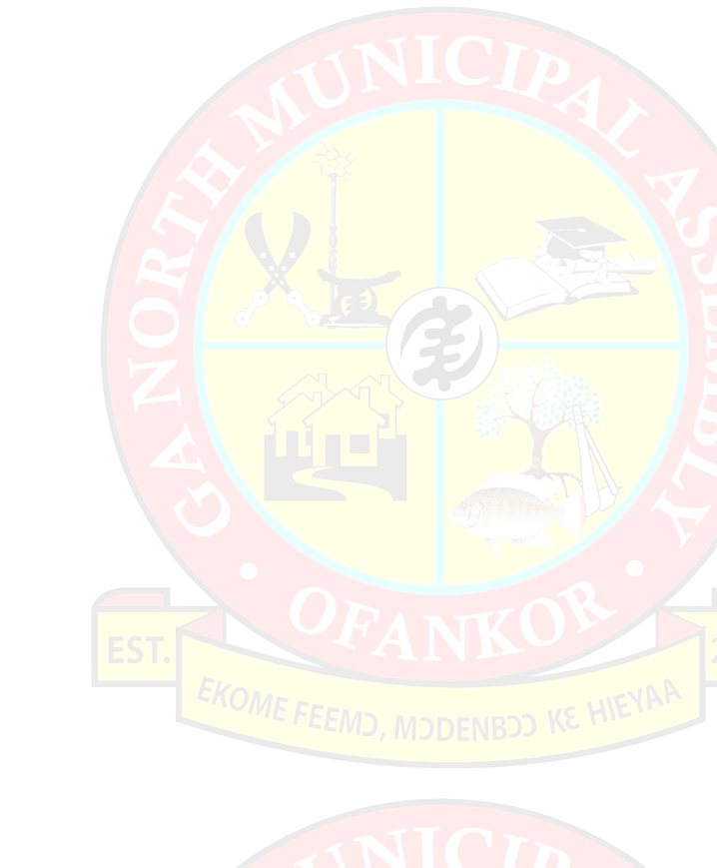
BOP BILL
BILL TO: DEOMETALS LTD
CUSTOMER: GNBOPOFNOFN000001

PHONE: 0244549446
ELECTRAL AREA: OFANKOR NORTH
STREET NAME: Ayasu, Ofankor
BUSINESS TYPE: MINING
LANDMARK:
OLD ACCOUNT NO:27393639200X
GPS COORDINATE: GG-294-2023
BILL NO:
BILL PERIOD: 2026
0.00
4,500.00
PLEASE NOTE
• Do not make any payment without this bill.
• It is an offence to deface the property number given by the G.N.M.A.
• It is an offence to change ownership of the property without informing the G.N.M.A Authorities.
• All dishonored cheque(s) shall attract a penalty of 100% of the face value of the cheque and defaulters will be liable for prosecution.
• Legal action shall be taken against defaulters after Bill Payment Date specified on the bill elapsed. Defaulters shall pay 50% penalty of the amount owed the Assembly.
• Payments should be made to the Ga North Municipal Assembly Authorized Revenue Collector(s) or at the Municipal Revenue Office.
• Obtain General Counteroil receipt (GCR) for all payment to the Assembly at all time.
NB:- Payments Points
*Revenue Collection Point
*Municipal Assembly Collection Point (Walk-in Service)
*Direct Payment / Bank Transfer Zenit Bank #6011811493
*Office Line - 0302-908-086

Printed On 23RD/ JANUARY/2026

BILL TYPE | CURRENT RATE(GHS) | AREARS  (GHS) | REBATE  (GHS) | TOTAL  (GHS)
Basic Rate Charge | 0.00  4,500.00 | 0.00 | 0.00 | 4,500.00

Amount Paid : GHS
Amount Due : GHS

